

**Publication Order Form: *Pilbara Native Plants for Gardens and Landscapes***

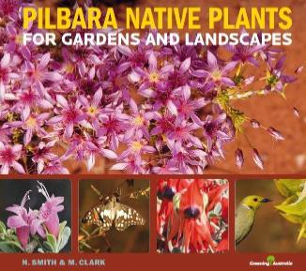

|  |  |  |  |
| --- | --- | --- | --- |
| **Unit Price (inc GST) Single = $22.22each** | **Quantity this Order MINIMUM OF 5** | **Postage** | **Total (GST inc.)** |
| **$22.22** |  |  | **$** |

Customer details:

|  |  |  |  |  |  |  |  |
| --- | --- | --- | --- | --- | --- | --- | --- |
| Contact Name: | |  | | | | | |
| Company / Organisation: | |  | | | | | |
| ABN Number | |  | | | | | |
| Purchase Order Number | |  | | | | | |
| Invoice address: | |  | | | | | |
|  | | | | | |
| Suburb: |  | | | State / Postcode: |  |
| Phone: |  | | | Email: |  | | |

Payment details:

By Direct deposit only. When we receive your order we will send you an invoice for payment. Greening Australia Ltd - ABN 40 002 963 788

*Books will be Posted to you on confirmation of payment.*

***Return completed form to:***

**Greening Australia Perth Office**

**Office use only: Date received:**

**Date Processed: Date Dispatched:**

Suite 2, Level 2,

8 St Georges Terrace, PERTH WA 6000 Phone: 08 9287 8300

Email: [per.general@greeningaustralia.org.au](mailto:per.general@greeningaustralia.org.au)