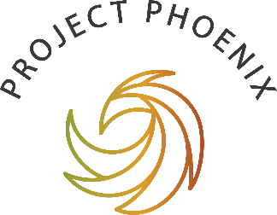

Project Phoenix Submission Cover Page

How to make a written submission
Public submissions on the National Ten-Year Strategy and the Code of Practice Options Paper are open from Monday 5 July to Monday 2 August 2021. (Please note that we have extended the 4-week consultation period by adding an extra 2 days to Monday 2 August. Due to the short timeframe, no additional extensions can be granted.)
You can have your say by:
If you would like to make a written submission, email your response to phoenix@greeningaustralia.org.au (Word documents are preferred). Please fill out this cover-page with your details and include as an attachment in the email with your submission.
Contacting Project Phoenix
If you have any problems sending your submission, or if you have any questions, please contact us for help at phoenix@greeningaustralia.org.au or phone us on 1300 886 589.
For information about Greening Australia's data collection and privacy policy, please visit:
https://www.greeningaustralia.org.au/privacy/

For us to have some information about the people giving us feedback, please answer the questions below to ensure we have captured a range of opinions across the sector?

Your best email address:

Full Name:

Your Postcode:

Are you submitting your feedback as an individual or on behalf of an organisation?

What is the name of your organisation?

What is your role in the sector?

Are you Aboriginal or Torres Strait Islander? (It is optional to answer this.)

Are you happy for your submission to be made public?

I would like my submission to remain confidential.

Thank you for your contribution. Your views are valuable, and all will be considered for the final Code of Practice document.

If you are not already a member of the Phoenix seed network, please subscribe below:
Project Phoenix Network

